Travel Brochure Book Report Project Name________________________ Per _____
You have read a fantasy or science fiction book. Now imagine that you own a tour company that is going to take guests on a tour of the lands (or other places) in your book. A real tour company in Costa Rica might offer a tour of a reptile center where guests can feed and pet the creatures; a zipline tour of the rainforest canopy; and a river rafting tour with a hike up a volcano. A Harry Potter tour company might offer a tour of the dining hall at Hogwarts, where guests can dine with the characters; a tour of Snape’s class where they can attempt to make potions and get turned into mice if they fail; and a tour of the sky in a flying car. So think about your book and decide a) on 3 different settings and b) what activities your guests could do there. All books have settings, even if they are realistic (attic, classroom, kitchen, taxi cab, bus). If your settings are dangerous, like in The Hunger Games, you can decide whether guests will put their lives on the line or if they will participate in a simulation or even just tour the area. You should have three panels on one side of the sheet and three panels on back, so you can fold it like a brochure. You can print double sided, or you can print single sided but glue the sheets together. 15 points per panel + 10 for grammar and spelling = 100 points.
INSIDE FLAP  Describe some of the dangers a tourist would face on your tour.  Give advice so the tourist can have a safe and happy adventure. | BACK COVER  Explain how to get to the tour company’s office or to the tour destination. What transportation could a tourist use? What directions should she follow?  Include a map. | FRONT COVER  Name of Your Tour Company  Based on (book title) by (author)  Your Local Guide: Student’s Name  Include a fake quote from a character with his/her opinion of the company.
ADVENTURE 1  Name a setting (a place from your book) and an activity that tourists could do there.  Use bold lettering and center it.  Include a picture of the place. Make it up or get it online.  Write descriptively about the setting (the place) so the reader can imagine it clearly.  Describe the activity that the tourist would do in this place.  Include some fun details, such as who the tourists might run into, the weather, what to wear or bring, where to eat or sleep, what to expect, or fascinating facts. | ADVENTURE 2  Name a setting (a place from your book) and an activity that tourists could do there.  Use bold lettering and center it.  Include a picture of the place. Make it up or get it online.  Write descriptively about the setting (the place) so the reader can imagine it clearly.  Describe the activity that the tourist would do in this place.  Include some fun details, such as who the tourists might run into, the weather, what to wear or bring, where to eat or sleep, what to expect, or fascinating facts. | ADVENTURE 3  Name a setting (a place from your book) and an activity that tourists could do there.  Use bold lettering and center it.  Include a picture of the place. Make it up or get it online.  Write descriptively about the setting (the place) so the reader can imagine it clearly.  Describe the activity that the tourist would do in this place.  Include some fun details, such as who the tourists might run into, the weather, what to wear or bring, where to eat or sleep, what to expect, or fascinating facts.

Travel Brochure Book Report Model
Hazards  Dangers: Most visits to the Star Wars universe are trouble free, however there is an underlying threat of being caught up in violence, and entire planets have been destroyed with the Empire’s Death Star.  Advice: Respect local customs and avoid discussing politics when visiting imperially controlled regions. Smuggling is common so do not accept any offers to carry anyone’s bag, especially when flying Millennium Falcon Airways. | How to Get There  By car, boat, or train: Forget it.  By air: Millennium Falcon Airways offers daily nonstop flights to Endor, Hoth, and Alderaan. See your local travel agent for details.  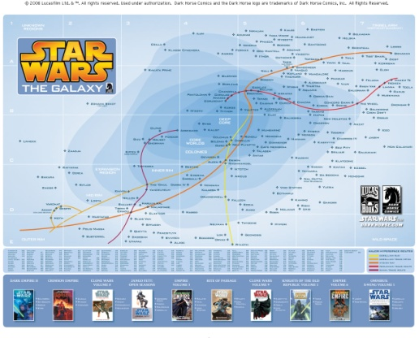 | ADVENTURE TOURS  based on Star Wars by George Lucas  your local guide: Amy Beeman-Solano  “Fun you will have, peace you will find, adventure you will remember, on Star Wars Adventure Tours” -- Yoda
Ewok Eco-retreat  on Endor  Popular with outdoorsmen, the forest moon of Endor is home to the Ewoks who run eco-tourism holidays. English is not widely spoken so you should bring an Ewokese phrase book, but the locals are very friendly. Staying in an Ewok tree house is a great way to experience their simple way of life.  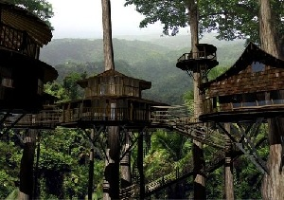  Though originally a hunter-gather society, following their appearance in the Star Wars films, the Ewoks now rely on tourism as their primary source of income. | Ski  Hoth, the Ice Planet  Hoth's endless winter means that snow sports are possible all year and the planet has become popular with the adventurous skiers and snowboarders. As there is no permanent population, fresh tracks can always be found, and the only competition for snow comes from an occasional member of the Rebel Alliance or the odd Imperial probe droid. There are no buildings, so you’ll need to sleep in a snow cave or the rebel's slightly more accommodating Echo Base. AT-ATs are also available for hire.  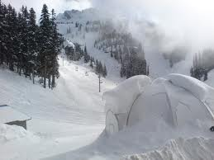 | Safari  on Alderaan  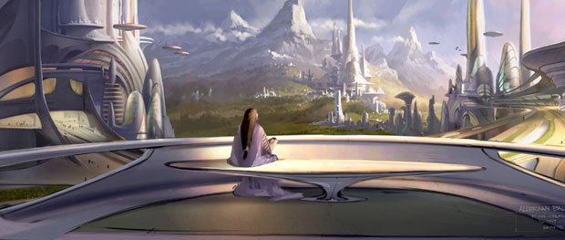  A beautiful planet characterized by grasslands, prairies and mountain ranges, Alderaan is extremely popular with nature enthusiasts.  Join an Alderaan safari where you can see more than 8000 species of wildflowers, and, if you’re lucky, catch a glimpse of the ‘big five’: Nerf, Grazer, Thranta, Stalking Bird, and Manka Cat.  Credit to:  http://www.skyscanner.net/news/articles/2011/07/010106-fantasy-holidays-quidditch-world-cup-ewok-eco-village-skiing-star-wars.html

