SCRAPBOOK BOOK REPORT

Cover (____/5):
Include character’s name, title of the book, author’s name, your name, and period.

Pictures (____/20):
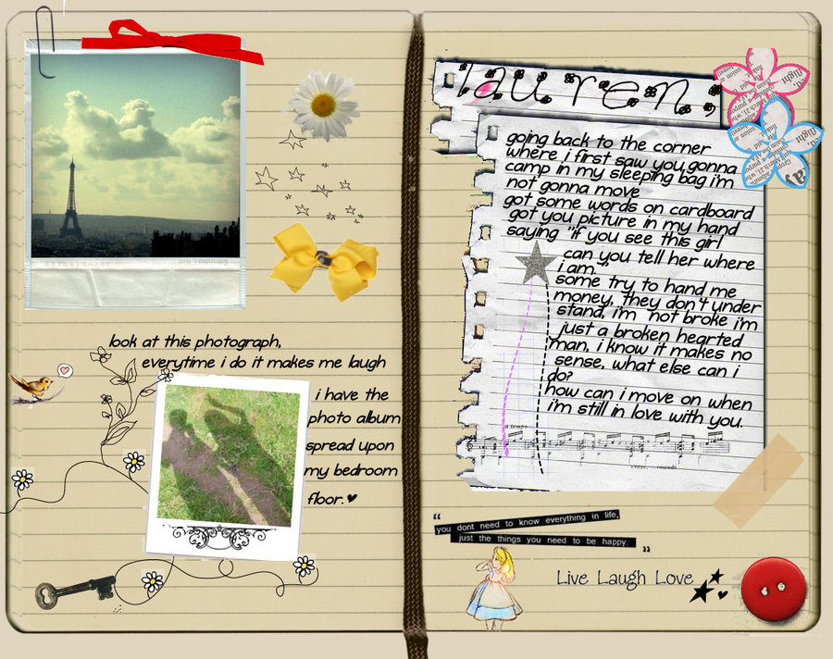

5 or more original drawings, photos, or online images show:
Character(s) and captions
Setting(s) and captions
Object(s) and captions

Two Letters (____/30):
Two characters write letters to each other in which they discuss a major problem and its resolution, or how one of the characters learns an important lesson in the book.

Souvenirs and Mementos (____/20):
Draw, create, collect or find at least five artifacts/souvenirs/mementos that the main character would put in his/her scrapbook. These objects can reflect events in the story or your character’s interests. Write one sentence next to each object to describe its significance.

Grammar (___/10)
Spelling, capitalization, grammar and punctuation are correct.

Overall look (___/15)
The overall look is creative and neat. Type or use ink. Layout is carefully planned.

CHARACTER’S BLOG BOOK REPORT

Home Page (____/5):
Include character’s name, title of the book, author’s name, your name, and period.

Pictures (____/20):

5 or more images that you have created or found online show:
Character(s) and captions
Settings(s) and captions
Object(s) and captions

Two Blog Entries (____/30):
In one entry, the character writes about his/her big problem using first person point of view (“I”).
In the second entry, the character writes about how he or she learned a lesson in the book.

Favorite links (____/20):
Insert hyperlinks to 5 websites that are important to the character. These links should reflect important events in the story or important aspects of your character. Write one sentence next to each hyperlink to describe its significance. Examples: favorite song, movie, historical event, online article, favorite artist, special place tourism page, favorite book, craft directions, favorite recipe, hero, etc.

Grammar (___/10)
Spelling, capitalization, grammar and punctuation are correct.

Overall look (___/15)
The overall look is creative and neat. The layout is carefully planned and makes use of multiple pages.

To turn in: Copy and paste your link in the Google Classroom. Make sure it’s the link for VIEWERS, not for you (the editor), or I won’t be able to open it.

To start: Create a free account at weebly.com * Don’t use your smmk12 account, or weebly won’t be able to communicate with you * choose “website” rather than “blog” format (it’s easier; trust me)

September Independent Reading
Your name Period
Title Author
# of pages _______ # of pages you read _______ book check ________
Main character:
Other important characters:
Setting (time and place):

How the book ends:

The character’s biggest problem:

Character’s fear, obsession, quirk, or passion:

The character’s best helper, friend, mentor, or sidekick:

