8th Grade Summer Reading Assignment:
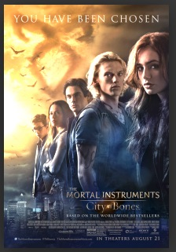
Movie Poster

Your summer reading book is being turned into a movie! Create an attractive poster that will intrigue people to come see the film.

Components:
- 8.5 x 11
- Your name and date
- Book title and author
- Brief plot summary (2-3 sentences)
- 1-5 star rating
- A tag line (i.e. One choice can transform you.)
- An illustration which captures the essence of the book
- Color/Decorated
- Four critics’ comments:
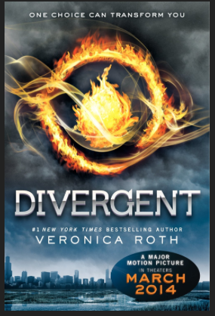
  - about a character
  - about the author or her writing style
  - a comparison to other books, movies or tv shows
  - something else—you decide (an opinion about the
setting, plot, originality, level of suspense, etc.)
Divergent by Veronica Roth

In a futuristic society, Beatrice Prior has to pick one of the five factions to which she will devote her entire life. She makes a surprising decision only to wonder if she’ll survive her new faction’s initiation process.

5 STARS!

DIVERGENT
One Choice Can Transform You

“…a STUNNING performance by Beatrice Prior. You’ve never seen a braver Dauntless initiate.”

“Veronica Roth’s writing is griping and will pull you in. You’ll hate to finish this story.”

“…if you liked Hunger Games, you’re going to LOVE Divergent!”

“…the chemistry between Tris and Four is sizzling! It will have you swooning!”

(Draw the picture here.)
